**Munin MongoDB Plugin:**

There are additional Munin plugins to measure the internal state of MongoDB which are not part of the default Munin install.

Check out from git:

>sudo git clone <http://github.com/erh/mongo-munin>

Copy the files which start with mongo under mongo-munin to /etc/munin/plugins.

Symlink these files from /usr/share/munin/plugins

[ec2-user@ip-10-29-25-157 ~]$ sudo ln -s /etc/munin/plugins/mongo_btree /usr/share/munin/plugins/mongo_btree

[ec2-user@ip-10-29-25-157 ~]$ sudo ln -s /etc/munin/plugins/mongo_conn /usr/share/munin/plugins/mongo_conn

[ec2-user@ip-10-29-25-157 ~]$ sudo ln -s /etc/munin/plugins/mongo_lock /usr/share/munin/plugins/mongo_lock

[ec2-user@ip-10-29-25-157 ~]$ sudo ln -s /etc/munin/plugins/mongo_mem /usr/share/munin/plugins/mongo_mem

[ec2-user@ip-10-29-25-157 ~]$ sudo ln -s /etc/munin/plugins/mongo_ops /usr/share/munin/plugins/mongo_ops

restart the munin-node service

[ec2-user@ip-10-29-25-157 ~]$ sudo service munin-node restartStopping Munin Node agents: [ OK ]

Starting Munin Node: [ OK ]

[ec2-user@ip-10-29-25-157 ~]$ sudo service httpd restart

Stopping httpd: [ OK ]

Starting httpd: [ OK ]

You should see the relevant Munin/Mongodb graphs:

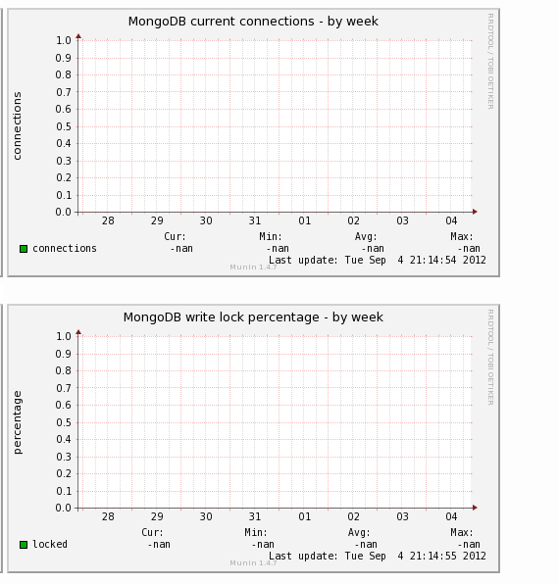

These graphs will fill in over time. They are blank because they were just installed.